|  |  |
| --- | --- |
| Date | 10 november 2023 |
| Team ID | NM2023TMID05030 |
| Project name | Leveraging Data Analysis for Optimal marketing Campaign success |
| Maximum marks | 10 marks |

**Leveraging Data Analysis for Optimal marketing Campaign success**

**1.INTRODUCTION**

**1.1 PROJECT OVERVIEW :**

**"**Leveraging Data Analysis for Optimal marketing Campaign success" The purpose of this project is to explore the application of data analysis in the context of marketing campaigns and demonstrate how it can be leveraged to achieve optimal success. By harnessing the power of data, marketers can go beyond traditional intuition-based strategies and adopt a data-driven approach to create more targeted and personalized campaigns. This project aims to provide insights into various data analysis techniques, tools, and methodologies that can be employed to uncover hidden patterns and trends in marketing data, enabling marketers to make informed decisions and optimize their campaigns for maximum impact.

**1.2 PURPOSE :**

Marketing campaigns can increase your brand awareness and enable you to reach new customers. They also inform your target market about your latest products and services, build reputation, and engage consumers. In other words, they are absolutely vital for any business.

**2.LITERATURE SURVEY**

**2.1 EXISTING PROBLEM :**

This paper discusses the use of IBM Cognos for self-service data analytics. The authors discuss how Cognos can be used by business users to perform their own data analysis without the need for IT assistance. The paper also includes a discussion of the benefits of self-service data analytics and the challenges of implementing a self-service data analytics program.

**2.2 PROBLEM STATEMENT DEFINITION :**

Marketing campaigns can increase your brand awareness and enable you to reach new customers. They also inform your target market about your latest products and services, build reputation, and engage consumers. In other words, they are absolutely vital for any business.

**3. IDEATION AND PROPOSED SOLUTION**

**3.1 EMPATHY MAP CANVAS :**

An empathy map is a simple, easy-to-digest visual that captures knowledge about a user's behaviours and attitudes. It is a useful tool to helps teams better understand their users.

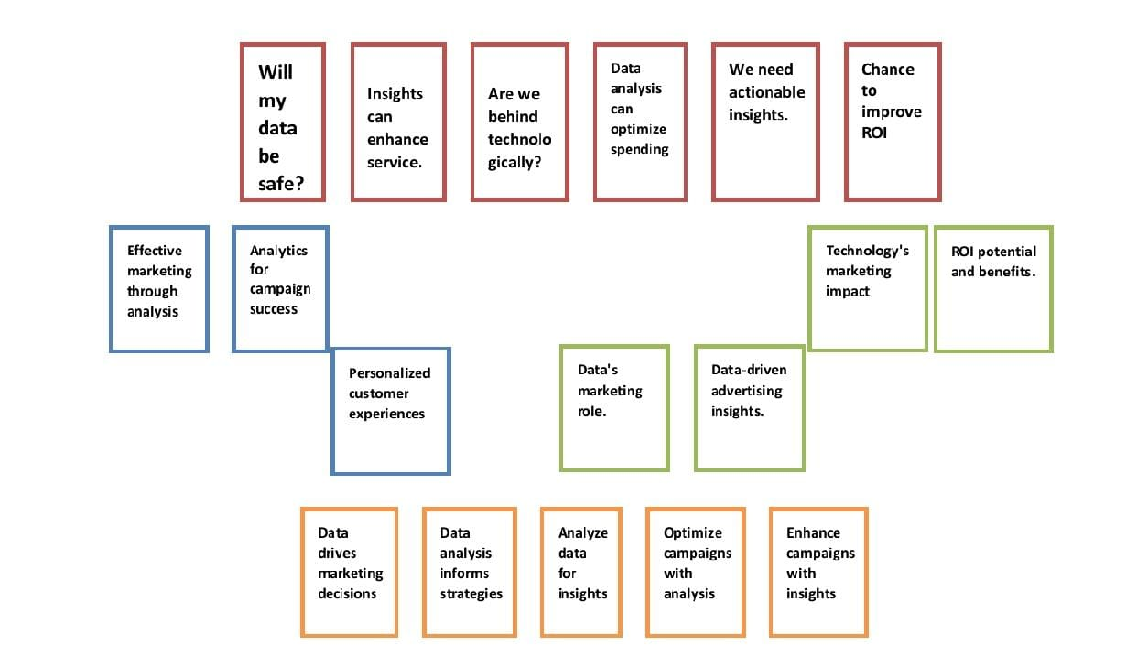

Creating an effective solution requires understanding the true problem and the person who is experiencing it. The exercise of creating the map helps participants consider things from the user’s perspective along with his or her goals and challenges.

**3.2 IDEATION AND BRAINSTORMING :**

Brainstorming provides a free and open environment that encourages everyone within a team to participate in the creative thinking process that leads to problem solving. Prioritizing volume over value, out-of-the-box ideas are welcome and built upon, and all participants are encouraged to collaborate, helping each other develop a rich amount of creative solutions.

Use this template in your own brainstorming sessions so your team can unleash their imagination and start shaping concepts even if you're not sitting in the same room.

**STEP:1 Team Gathering , Collabatiom and Select the Problem Statement**

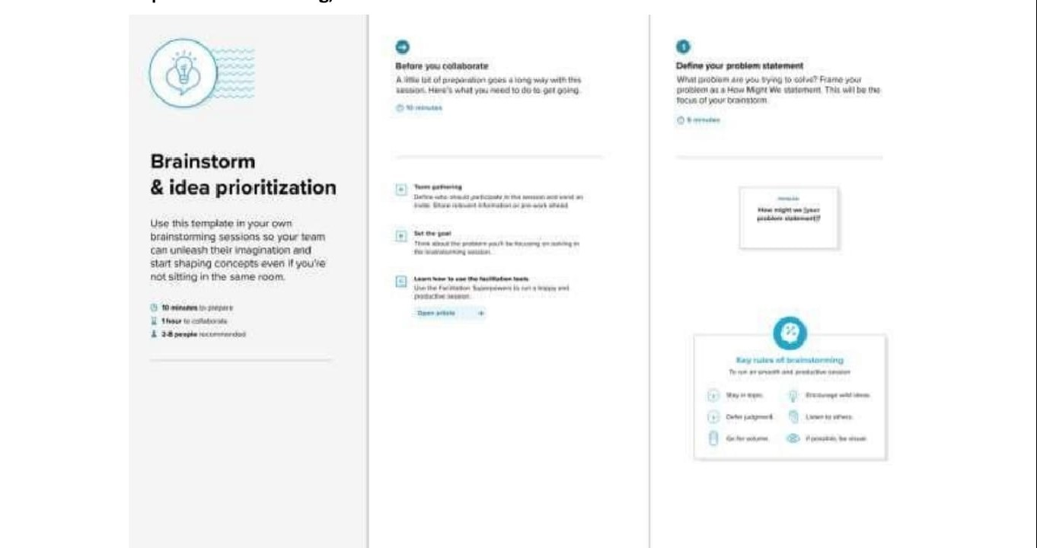

**Problem**

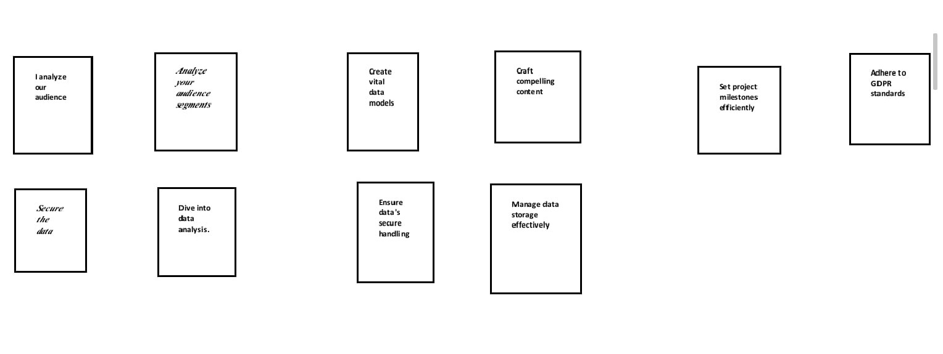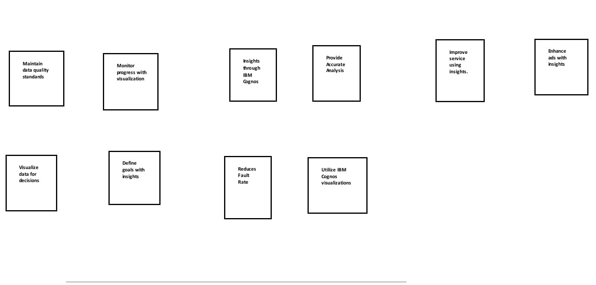The real problem is there is no proper visualizations for analysing data. So by using “IBM COGNOS ANALYSIS” we can provide our solutions through various visualizations for our topic “Leveraging Data Analysis for Optimal Marketing Campaign Success“

**STEP :2 Brainstorm , Idea Listing and Grouping**

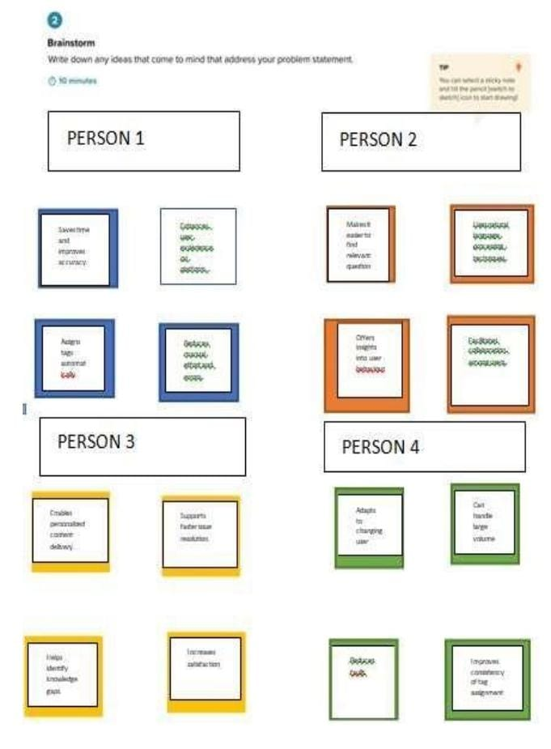

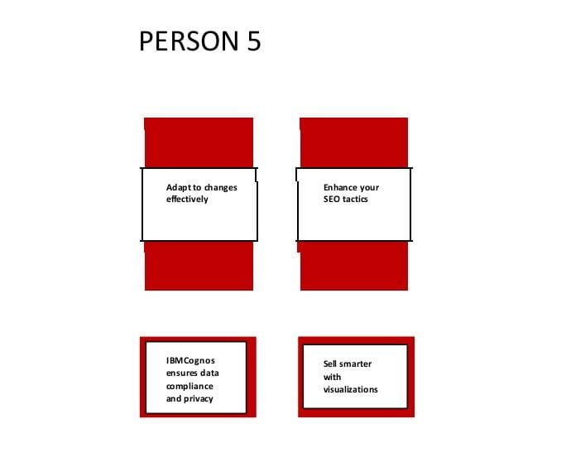

**4.BUSINESS REQUIREMENTS**

To create a successful marketing campaign leveraging data analysis, you'll need to establish clear business requirements. These requirements will serve as the foundation for your project and help guide your data analysis efforts. Here are some essential business requirements for our project titled "Leveraging Data Analysis for Optimal Marketing Campaign Success.

1. Campaign Goals and Objectives

2. Target Audience

3. Key Performance Indicators (KPIs)

4. Data Sources

5. Data Collection and Integration

6. Data Analysis Tools and Technologies

7. Data Privacy and Compliance

8. Budget and Resource Allocation

**5.DATA FLOW DIAGRAMS :**

A Data Flow Diagram (DFD) is a traditional visual representation of the information flows within a system. A neat and clear DFD can depict the right amount of the system requirement graphically. It shows how data enters and leaves the system, what changes the information, and where data is stored

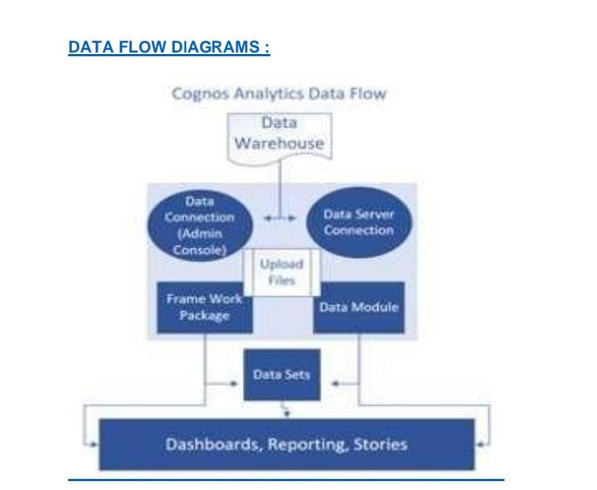

**USER STORIES :**

Use the below template to list the user stories for the product

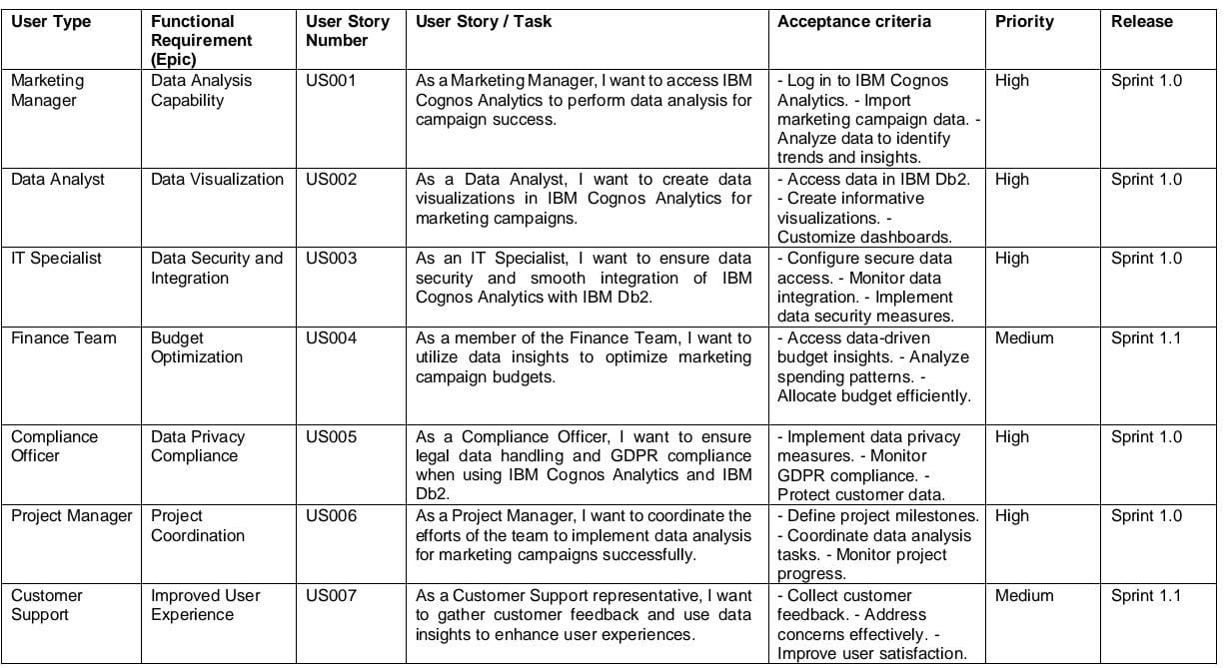

**PROJECT DESIGN PHASE SOLUTION ARCHITECTURE :**

Solution architecture is a complex process – with many sub-processes – that bridges the gap between business problems and technology solutions.

Its goals are to:

• Find the best tech solution to solve existing business problems.

• Describe the structure, characteristics, behavior and other aspects of the software to project stakeholders.

• Define features, development phases, and solution requirements.

• Provide specifications according to which the solution is defined, managed and delivered.

**Example - Solution Architecture Diagram:**

